Project Work

For

Database Management System

**Submitted By: Submitted To:**

Shahil Jha Database Management

Basu Dev Subedi System Instructor,

Ananda Aryal Chakra Narayan Rawal

4th Semester, BIM

Project Description

This project has been done in a group of three with the goal of making a basic prototype working database for an e-library. The database software that has been use for this project is SQL Server.

The dictionary definition for e-library is, a digital library, a virtual library offering books in computerized form. In simpler words, an e-library is a library in a digital form that provide all the facilities that a physical library provides but in a digital interface. E-library provides services through a digital interface without the need for physically presence in the library and provides the content material through digital format.

Objective

* Make a basic working database for an e-library organization.
* To familiarize with database software and their application.

Description of Entities Considered in the Project

The entities that are considered in this project are the bare minimum entities required for the basic operation of an e-library organization. The considered entities for this project are as follows:

* Admin

The admin, as in administrator, is the person who manages the e-library organization. The administrator is responsible for all the database related operations of the organization. The admin makes it possible for the proper functioning of all the database services of the organization. Admin may be a single person or a team of people. Its attribute are:

1. admin_id(Primary Key)
2. name
3. username
4. password
5. entry_date

* Books

Books are the entity that defines the books that are available in the e-library. This entity denotes the digital formatted books that are provided in the e-library. Each book entity has a unique id that uniquely defines a book. Its attribute are:

1. book_id(Primary Key)
2. bookname
3. author
4. detail
5. entry_date

* Students

Students, as a whole, represent all the visitors or clients of e-library. This entity represents those who access the books from the e-library. Its attribute are:

1. s_id(Primary Key)
2. s_name
3. s_contact
4. s_address
5. s_gender
6. s_dob
7. s_email
8. s_password
9. entry_date

* Publication

This entity represents those publication from which the book has been published through. This attribute was considered in this project because it provides a variable through which a book may be identified more specifically. It can come in use in conditions where books may have similar title but different publications. Its attribute are:

1. p_id(Primary Key)
2. p_name

ER Diagram

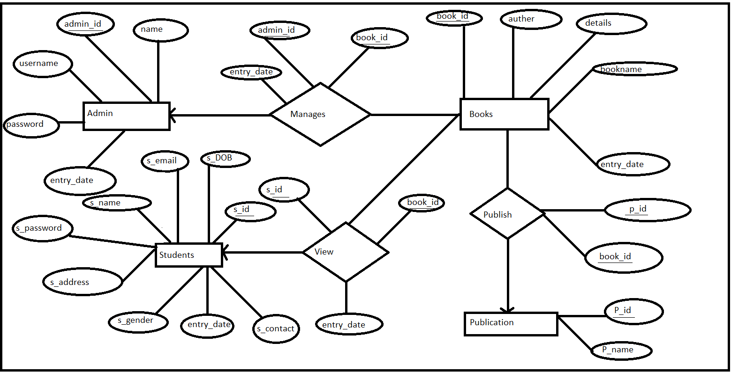

Schema Diagram

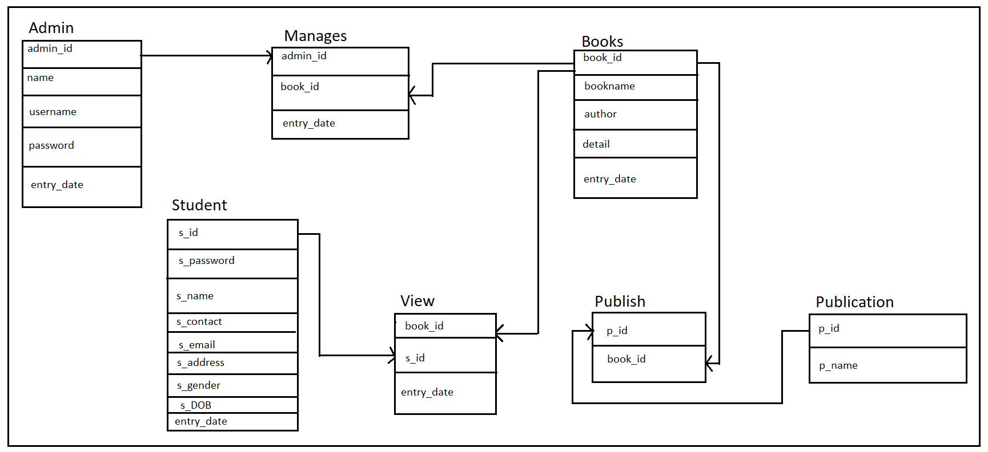

Implementation

Creation of Database

CREATE DATABASE project;

USE project;

Creation of Table for Each Entity and Relationship

CREATE TABLE admin(

admin_id int IDENTITY,

name varchar(30),

username varchar(15),

password varchar(15),

entry_date date,

PRIMARY KEY(admin_id)

);

SELECT * FROM admin;



CREATE TABLE books(

book_id int IDENTITY,

bookname varchar(30),

author varchar(20),

detail varchar(1000),

entry_date date,

PRIMARY KEY(book_id)

);

SELECT * FROM books;



CREATE TABLE students(

s_id int IDENTITY,

s_name varchar(30),

s_contact varchar(10),

s_address varchar(20),

s_gender varchar(6),

s_email varchar(20),

s_password varchar(15),

entry_date date,

PRIMARY KEY(s_id)

);

SELECT * FROM students;



CREATE TABLE publication(

p_id int IDENTITY,

p_name varchar(25),

PRIMARY KEY (p_id)

);

SELECT * FROM publication;



CREATE TABLE manages(

admin_id int,

book_id int,

entry_date date,

FOREIGN KEY (admin_id) REFERENCES admin,

FOREIGN KEY (book_id) REFERENCES books

);

SELECT * FROM manages;



CREATE TABLE views(

s_id int,

book_id int,

entry_date date,

FOREIGN KEY (s_id) REFERENCES students,

FOREIGN KEY (book_id) REFERENCES books

);

SELECT * FROM views;

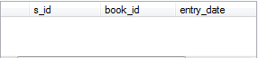

CREATE TABLE publish(

p_id int,

book_id int,

FOREIGN KEY (p_id) REFERENCES publication,

FOREIGN KEY (book_id) REFERENCES books

);

SELECT * FROM publish;

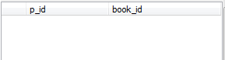

Insertion of Data

1. Admin Table

INSERT INTO admin VALUES('shahil jha','shahil','shahil','9/02/2019');

INSERT INTO admin VALUES('basu dev subedi','basu','basu','9/02/2019');

INSERT INTO admin VALUES('ananda aryal','ananda','ananda','9/02/2019');

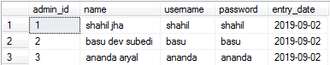

1. Books Table

INSERT INTO books VALUES('City of Girls','Elizabeth Gilbert','A SUNDAY TIMES TOP TEN BESTSELLER.','9/02/2019');

INSERT INTO books VALUES('The Testaments','Margaret Atwood','A sequel to her The Handmaids Tale.','9/02/2019');

INSERT INTO books VALUES('Three Women','Lisa Taddeo','THE NUMBER ONE NEW YORK TIMES BESTSELLER.','9/02/2019');

INSERT INTO books VALUES('Red at the Bone','Jacqueline Woodson','Gorgeous, moving…A story of love—romantic.','9/02/2019');

INSERT INTO books VALUES('The Nickel Boys','Colson Whitehead','The Nickel Boys is a 2019 novel by American novelist and writer Colson Whitehead.','9/02/2019');

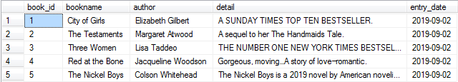

1. Publication Table

INSERT INTO publication VALUES('Originally Published');

INSERT INTO publication VALUES('McClelland & Stewart');

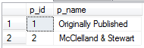

1. Students Table

INSERT INTO students VALUES('ram','9841123456','kathamndu','male','ram@gmail.com','ram','9/03/2019');

INSERT INTO students VALUES('sagar','9841123456','bahktapur','male','sagar@gmail.com','sagar','9/03/2019');

INSERT INTO students VALUES('kriya','9841123456','lalitpur','female','kriya@gmail.com','kriya','9/03/2019');

INSERT INTO students VALUES('jimmy','9841123456','kalanki','male','jimmy@gmail.com','jimmy','9/03/2019');

INSERT INTO students VALUES('reena','9841123456','kathamndu','female','reena@gmail.com','reena','9/03/2019');

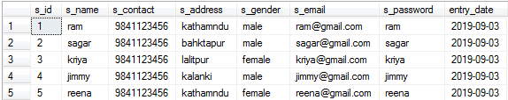

1. Publish Table

INSERT INTO publish VALUES(1,1);

INSERT INTO publish VALUES(2,2);

INSERT INTO publish VALUES(1,3);

INSERT INTO publish VALUES(1,4);

INSERT INTO publish VALUES(1,5);

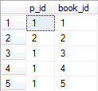

1. Manages Table

INSERT INTO manages VALUES(1,1,'9/03/2019');

INSERT INTO manages VALUES(1,2,'9/03/2019');

INSERT INTO manages VALUES(1,3,'9/03/2019');

INSERT INTO manages VALUES(1,4,'9/03/2019');

INSERT INTO manages VALUES(1,5,'9/03/2019');

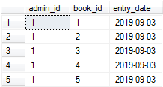

1. Views Table

INSERT INTO views VALUES(3,3,'9/04/2019');

INSERT INTO views VALUES(5,1,'9/05/2019');

INSERT INTO views VALUES(2,5,'9/07/2019');

INSERT INTO views VALUES(1,4,'9/11/2019');

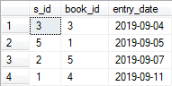

Conclusion of the Project

This project has been made with the goal of fulfilling the role of being used in a basic functioning e-library. The project database can be used in an e-library organization as it considers all the basic entities that are essential for a basic e-library to function.

The attribute ‘entry_date’ has the function of keeping records of all the activities. Through the use of this attribute in the ‘manages’ table, it tracks the activities of the administrator in relation to the books in the library. This can be used by the organization to keep track of the activities of administrator.

Through the use of this attribute in the ‘view’ table, it keeps track of which student has viewed which book. This data can be used by the organization to further enhance their system for better user experience.

This project considers the aspects that are essential for an e-library and it basic function of storing records of books that are in digital form, the administrator details and their client details. The database also considers the entry date of different activities in the e-library system for keeping tabs on what has been done, by whom it has been done and when it was done. This project is a prototype database for an e-library and can further be enhanced in accordance to the need and services provided by the organization. For example, this prototype considers only the books but not journals, article, newsletter, etc. Further additions depend upon the service and features of the organization.